**Introduction:**

* Whenever we want to build a docker image, we write Dockerfile (casing is important)
* In that we write simple instructions, nearly Linux commands and some docker keywords
* Docker provides a set of standard instructions to be used in the Dockerfile, like **FROM, COPY, RUN, ENV, EXPOSE, CMD, WORKDIR, USER, VOLUME, ENTRYPOINT, ONBUILD** just to name a few basic ones.
* Docker will build a Docker image automatically by reading these instructions from the Dockerfile.
* Every Dockerfile must start with the FROM instruction. The idea behind is that you need a starting point to build your image. You can start FROM scratch, scratch is an explicitly empty image on the Docker store that is used to build base images like Alpine, Debian and so on.

**Dockerfile Instructions:**

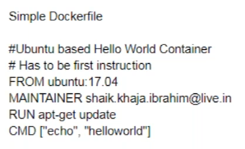

* To build docker image, need to take any existing image
* If we don’t want, we can also create from scratch using scratch image from docker hub
* In CMD, we write what must be there for starting the application

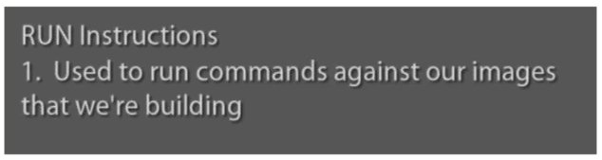

* Whenever image becoming container, it does what mentioned in CMD
* If any statement we execute, if it asks for the prompt to continue, docker will fail
* So, we need give -y to do that

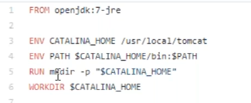

* Whenever we want to set environment variable inside container, we can use ENV
* And if we want to be in specific folder when we login to container, we need to set WORKDIR for that
* Whenever we write an application in a container which works on specific port, we need to mention that as expose



* We can write multiple ports if it required more than one also
* Now, we can create docker file as below to copy Jenkins.war file to webapps folder

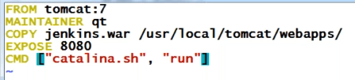

* ADD and copy are almost same
* ADD is used to download from internet with URL whereas copy used to copy the file which is present in local server
* ADD is used to copy from local server also
* We can also use wget command in RUN instruction instead of ADD command to download something from internet

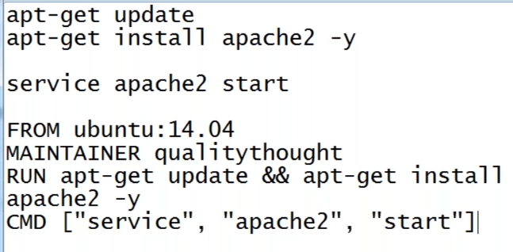

* Dockerfile can be with any name, the restriction was there earlier, but now its fine but still people are creating file with Dockerfile name
* Run is used to image build, it contains what image should have
* CMD have what needs to be done when contains is getting created
* **Docker build -t myapache:1.0 <path>**
* **Docker build -t myapache .**
* Above command used to build the image, -t means tag, if the docker file is in current path, we can use . instead of path
* If we don’t give tag version, it will take it as latest
* Docker build is used to create image out of docker file
* After building, we can see two images, one is the image of OS and other is the one which we have written
* Now we can run the image using docker run command

**USER:**

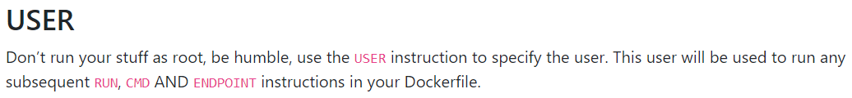

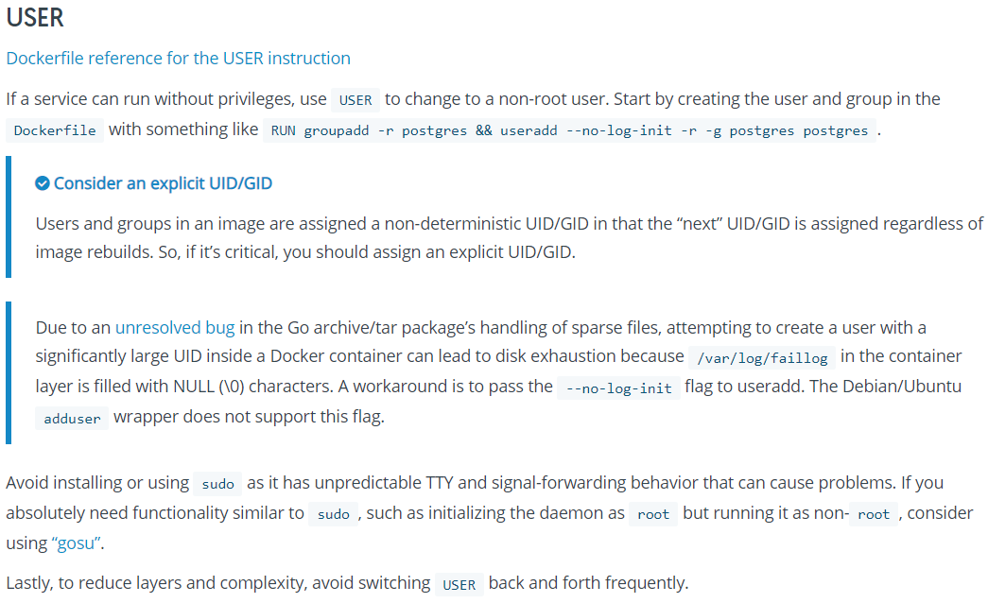

**ENTRYPOINT:**



* If we give anything after the image name in command, it will be replaced to the CMD in docker file
* **Example,** if we have mentioned ping google.com as CMD in docker file and while executing if we use ping yahoo.com as below, it will be replaced with yahoo.com
* **Docker run myapache:1.2 ping yahoo.com**
* During run time, it will be overwritten
* We can also write in below method also

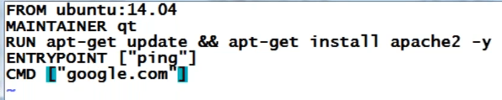

* Now, whatever we write in entry point will happen, CMD will be an argument for the entry point
* So, when you are passing anything after image name, it will overwrite only CMD, not entry point
* **Docker run myapache:1.2 yahoo.com**

**LABEL:**

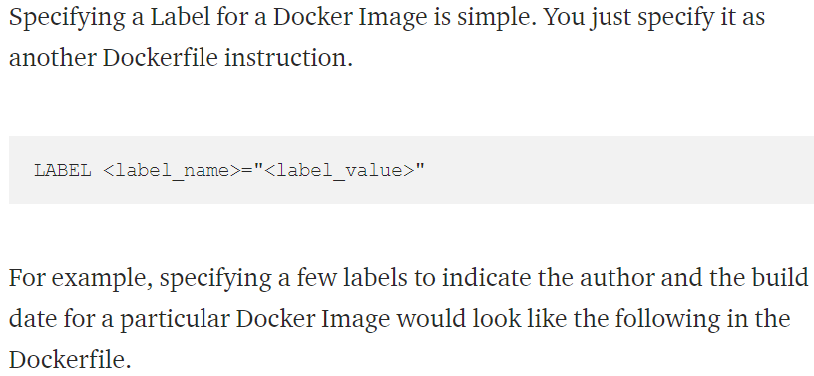

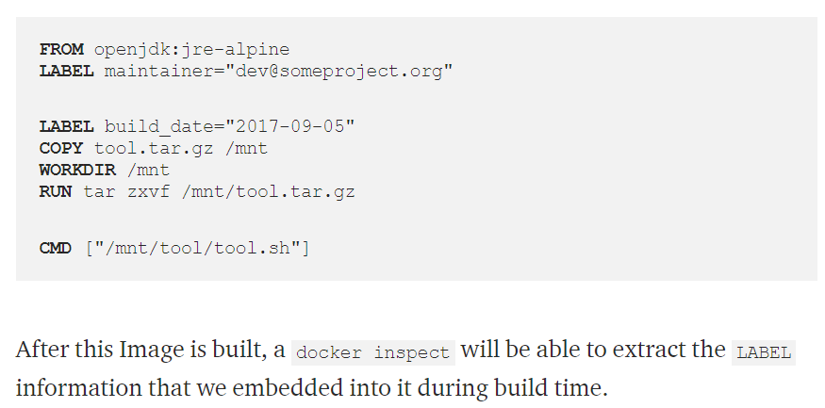

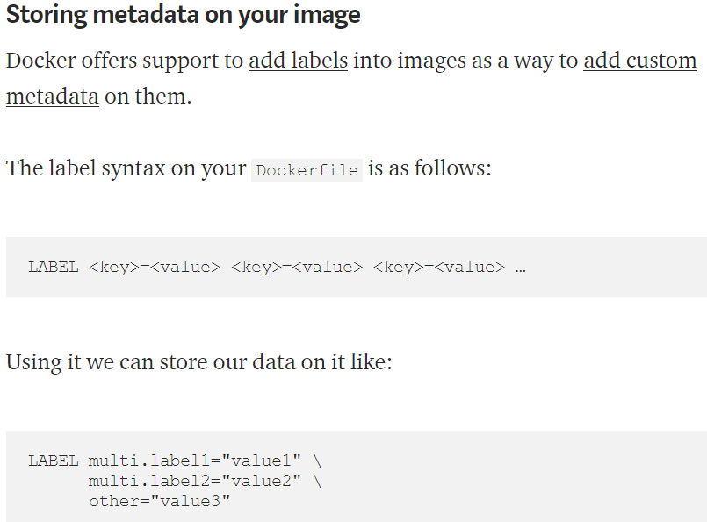

This can be used to store the metadata of image like the author who is responsible for the image, date of image build. What is the code fix made in this image etc.

**ONBUILD:**

